*PERSONAL TECHNICAL REPORT*

*BY-SANDEEP SINGH*

*ST.ID-M228854*

TABLE OF CONTENTS

* INTRODUCTION………………………………………………………………………….
* PLANNING………………………………………………………………………………….
* PERSONAL DATA……………………………………………………………………….
* PROGRESS………………………………………………………………………………….
* DISCUSSION ………………………………………………………………………………

INTRODUCTION

The objective of this report is to inform and update our lecturer on how our project of converting and *Old Manual Lathe in to CNC lathe* is going.

Our primary goal for the Semester 1 was to automate a ***Colchester Student 1800 Lathe*** that was originally completely mechanical. To complete this, we decided that it was best to separate the work load.

Semester 2 –Goal for this semester is programming, before that it includes jobs like painting of lathe, afterwards installing the CNC parts (motion controller, sensors and another electrical stuff).

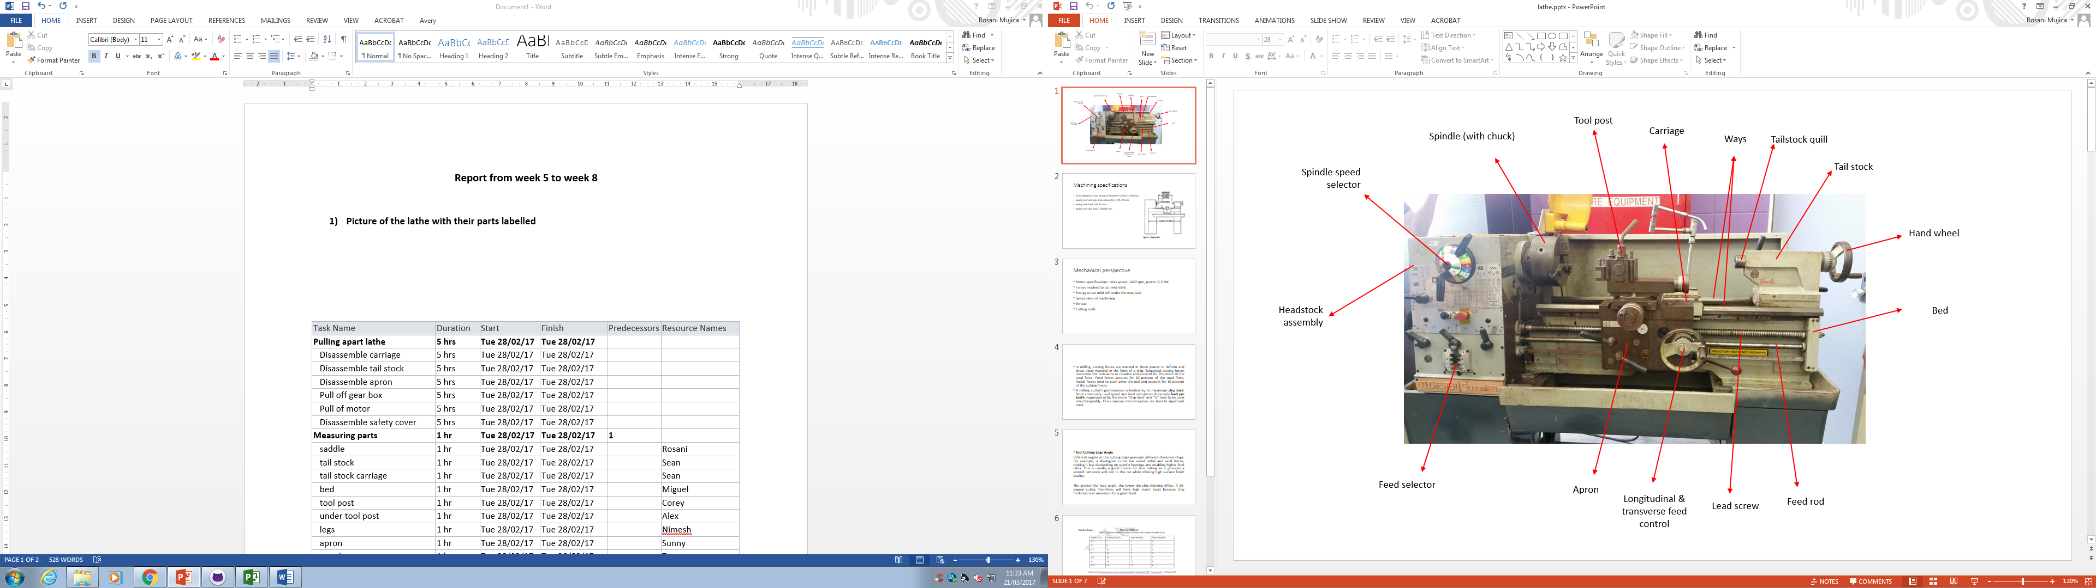

My contribution

* Handling the electrical portion.  
  (Collecting data from internet for sensors and switches.)
* Making the inventor drawings for chucks and chuck holder.
* Helping the team which is making covers for lathe.
* Cleaning of the Lathe.
* Made the updated Group Progression Report.

Data collected on 4 sensors with attached internet links including price, specifications (shown with details in the personal progress report)

These are the sensors required for the CNC lathe.

1. Slide door sensor detect movement and are installed on the sides of the door.
2. Limit switches used for controlling machinery as part of a [control system](https://en.wikipedia.org/wiki/Control_system).
3. The purpose of a float switch is to open or close a circuit as the level of a liquid rises or falls.
4. We are using 2 sensors for homing cycle.

|  |  |  |  |
| --- | --- | --- | --- |
| Ser.no | Number of sensors | Sensor researched | Total price |
| 1 | 1 | Slide door sensor | 278.76 |
| 2 | 4 | Limit switch | 93.84 |
| 3 | 1 | Float switch | 17.54 |
| 4 | 2 | Inductive sensor | 36.53 |

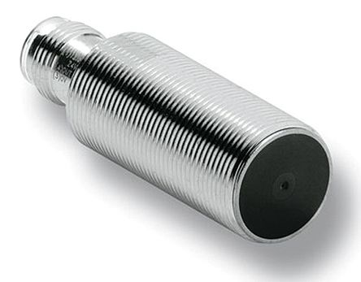

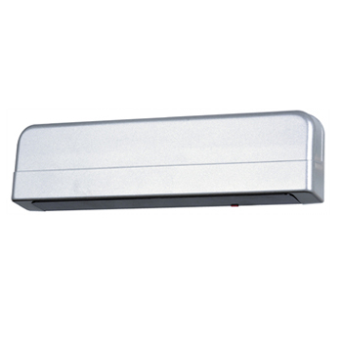

3 jaw chucks,4 jaw chucks and chuck holder inventor drawings.

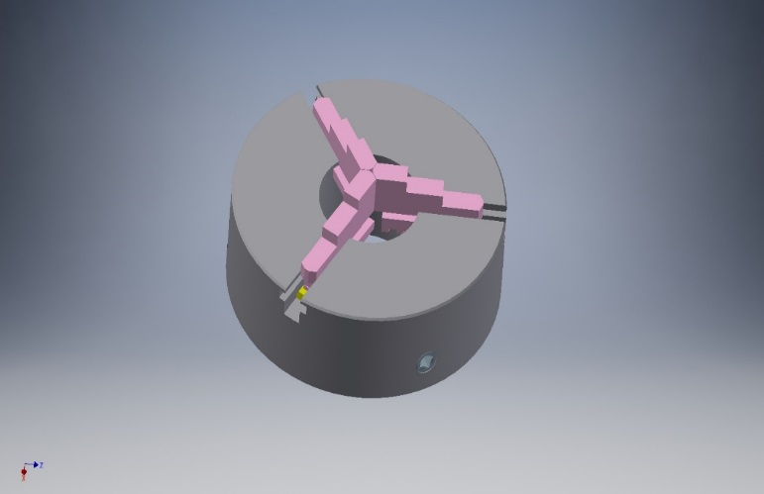

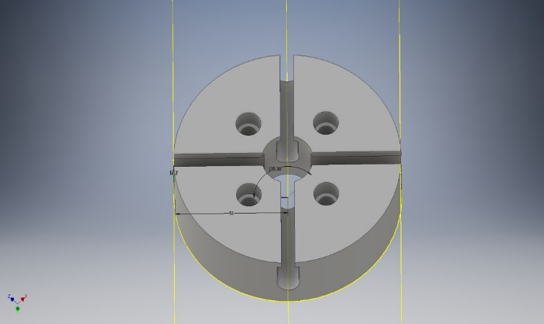

After that we installed new parts in model along with chuck. I helped my group members to modify Cross-slide and removed some old parts from bed of lathe.

This is lathe assembly with updated parts.

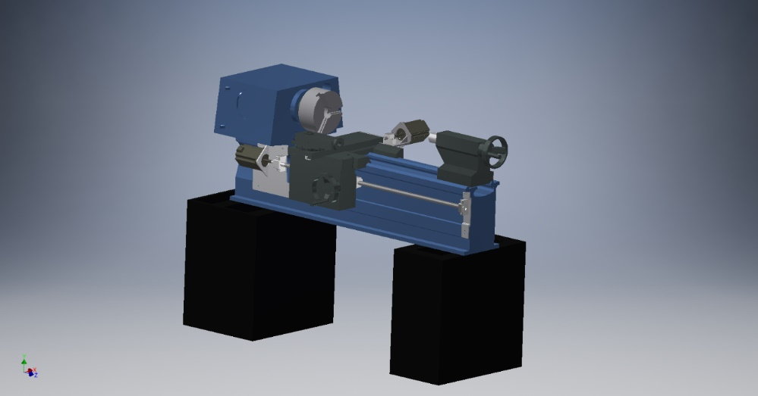

I created new drawing in Autodesk inventor of part called ‘Tool Post’.

I helped my group members to modify Cross-slide and

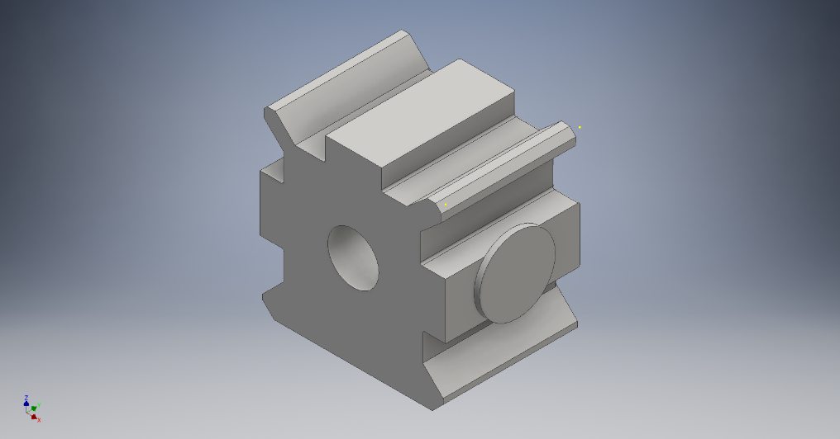

DISCUSSION

This was the progress of our project so far. We tried our best to finish the conversion of old manual lathe CNC lathe. Our group has made budget list for parts and they need to be installed for further processing of group We finalised the model along with force analysis, we hand this project to our lecturer or to next group so that they can make changes further including the positioning of sensors, motors because new parts has not been installed yet.